# From Home Office to Gym: The Importance of Physical Activity for IT Professionals

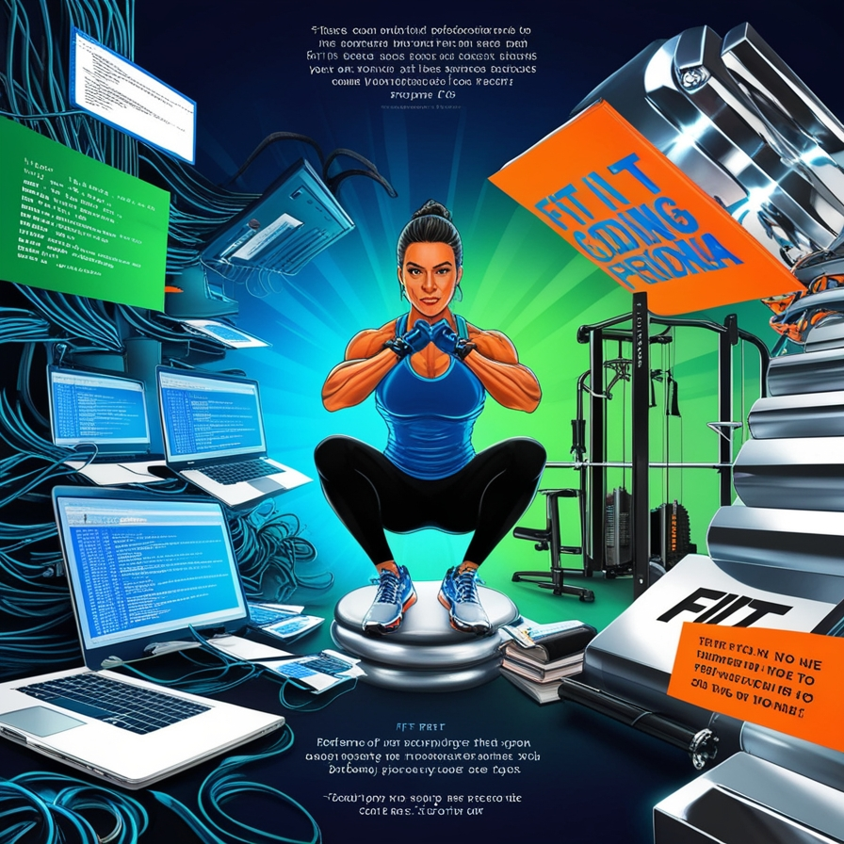

Introduction

In today's scenario, many IT professionals have shifted to working from home, which has brought benefits such as flexibility and time savings. However, this change has also created challenges, particularly concerning health and well-being. The lack of movement and prolonged computer use can lead to a range of health issues, such as back pain, eye fatigue, and cardiovascular problems. This text explores the importance of physical activity for IT professionals and offers practical strategies for incorporating exercise into the remote work routine.

Benefits of Physical Activity for IT Professionals

### Improvement of Physical Health

Regular physical activity is crucial for maintaining physical health. Exercises such as walking, running, and strength training help prevent problems like obesity, heart disease, and diabetes. For IT professionals, who often spend long hours sitting, exercise can relieve muscle tension, improve posture, and reduce the incidence of back and neck pain.

### Increase in Productivity

Studies show that physical activity not only improves overall health but also boosts productivity. Regular exercise can enhance concentration, memory, and problem-solving abilities—skills essential for IT professionals. Additionally, breaks for physical activity help combat mental fatigue and stress, resulting in greater efficiency at work.

### Reduction of Stress and Improvement of Mental Well-Being

Physical exercise is an effective way to reduce stress and improve mental well-being. Activities such as running, yoga, and meditation promote the release of endorphins, neurotransmitters that improve mood and reduce anxiety. For IT professionals, who may face constant pressure and tight deadlines, physical activity provides a valuable means of managing stress and enhancing mental health.

Strategies for Incorporating Physical Activity into Home Office Routine

### Establish a Routine

Creating an exercise routine is crucial to ensure physical activity is incorporated into daily life. Set specific times for exercise, whether in the morning before starting work, during lunch breaks, or in the evening. Establishing a routine helps turn exercise into a habit and ensures it is not neglected.

### Take Active Breaks

Incorporating active breaks into your work routine is an effective way to stay active without interrupting work flow. Perform small exercises such as stretches, squats, or short walks every 30 to 60 minutes. These breaks help reduce muscle stiffness, improve blood circulation, and provide mental rest.

### Use Apps and Online Resources

Utilize apps and online resources to stay motivated and follow an exercise plan. Many fitness apps offer guided workouts, personalized exercise plans, and progress tracking. Platforms like YouTube also have a wide range of exercise and yoga videos that can be done at home.

### Create an Exercise Space

If possible, create a dedicated exercise space in your home. Having a specific area for exercise can increase motivation and consistency. Simple equipment such as a yoga mat, dumbbells, and an exercise ball can be sufficient for performing a variety of home workouts.

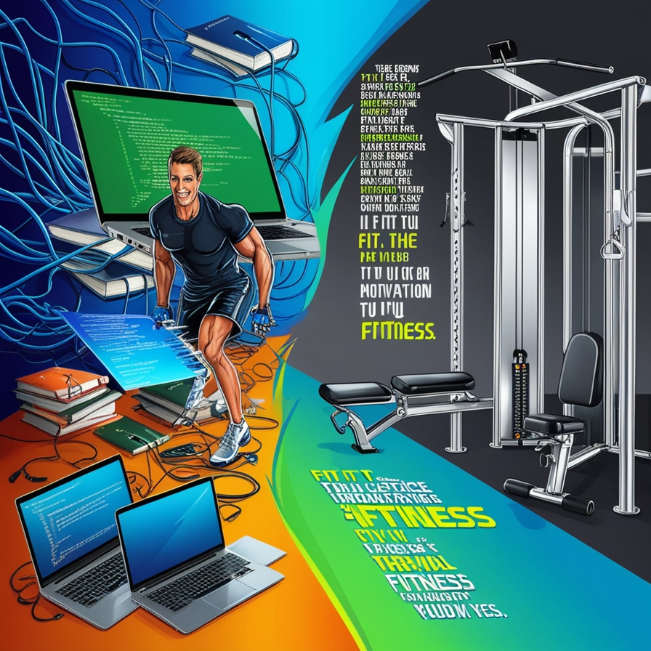

## Conclusion

Physical activity is essential for the health and well-being of IT professionals, especially those working from home. Incorporating exercise into the daily routine can improve physical health, increase productivity, and reduce stress. By establishing an exercise routine, taking active breaks, using online resources, and creating a dedicated exercise space, it is possible to stay healthy and balanced even while working remotely.

Investing time in physical activity is an important step towards ensuring a healthy and productive life, and it can positively transform both the physical and mental health of IT professionals.